

Student Conduct and Behavioural Management Policy

Revision number | V3
Effective | February 2018
Owner | Operations Manager: Learner Journey
Review date | August 2018

Student Conduct and Behavioural Management Policy

Buxton & Leek College sets high standards and has high expectations of its students. We expect students to demonstrate a high level of respect for their peers, staff, employers and the public. We expect students to develop their understanding of their rights and responsibilities as a student and, where relevant, as an employee, and as citizens and members of the community. We expect you to be an ambassador for your programme and the College, demonstrating the skills and behaviours you have learned. We expect you to use the attributes you develop to distinguish yourself during your time at College and beyond.
Our student conduct and behaviour policy is based on the following principles:
- Unwanted behaviour including on line activity is behaviour likely to hurt, injure or upset another member of the college, work place or community.
- Unwanted behaviour shows lack of respect for others, disrupting their activities and learning.
- All students have the right to learn in a safe inclusive environment.
Through the implementation of this policy, the college aims to clarify the difference between acceptable and unacceptable behaviour and the consequences of inappropriate behaviour. Where necessary students will be supported and helped to develop self-discipline, respect for the needs of others and respect for their own and others property.
We endeavour to apply rules fairly, clearly and consistently. In the case of particularly serious incidents or persistent unacceptable behaviour we will always endeavour to involve parents/carers of students under 18 (over 18 with student’s agreement) in resolving the situation.
Appropriate behaviour is modelled by the teaching and non-teaching staff at Buxton & Leek College. We expect that this aim to model appropriate behaviour is supported by the parents/carers at Buxton & Leek College so that students are given clear and consistent guidance.

- Behaviour for learning
We aim
- To promote the values of the college and the good behaviour of students
- To establish a positive, friendly ethos based on mutual respect and trust
- To ensure students, parents/carers and staff understand and uphold the values and expectations of the college
- To celebrate success
- To enable students to realise their full potential in a safe and positive learning environment
- To ensure systems of recording and reporting support the effective implementation of the procedures for celebration and cautions
Our principles are
- The behaviour of students reflects the values upheld by the college community
- The fundamental British Values of democracy, the rule of law, mutual respect and individual liberty of students is demonstrated in their behaviour
- Students have clear guidance and consistent consequences
- The partnerships between home, college, work and the student is essential to promote positive behaviour
- All students feel and are safe

- Scope

- The Student Conduct and Behavioural Policy will be applied to all students on college premises and where they represent the college externally (for example at work, on college buses and outside the college where students are taking part in organised trips and events)
- Where student behaviour will affect the reputation of the college or may place other students at risk

- Celebrating success and achievement
We aim to celebrate student success and recognise achievement and good behaviour, through:
- Cause for celebration
- Awards events

- Responding and Recording to incidents of unacceptable behaviour
Advisory  Note | Any member of staff can issue an Advisory note.  See Appendix 1 for definition  Procedure:  - Staff member to issue Advisory note on eTrackr. In description section write Advisory notice and details of concern  - Change disciplinary status to ‘Advisory Note’ from student home page  - Notify Course Tutor either through eTrackr or email  - Within 1-2 days an informal meeting will be held between the student and Course Tutor to discuss the issues and agree actions  - Sanctions- Course Tutor will monitor and review behaviour 2 weeks later and place a note on eTrackr informing that the behaviour is resolved or to escalate to C4C L1  * For LAC issues must be raised with the College link advisor in the Learner Journey Team SOR (Leek) EM (Buxton)
Cause for Concern Level 1 | Meeting organised by Progress Coach.  Course Tutor or Maths/ English Tutor will attend with student within 2 days of issue.  See Appendix 1 for definition  Procedure:  - Following 1-1 meeting with the student the Progress Coach must add Cause for concern (C4C) record on eTrackr. In description section write Level 1 and details of concern  - Change disciplinary status to ‘Level 1’ from student home page  - Attach cause for concern paperwork onto eTrackr  - Agreed actions must be written in the section on the C4C eTrackr entry  - Sanctions-Behaviour Contract to be put in place. Tutor to monitor student and hold a review meeting within 2 weeks where, if concern persists, agree further actions which may include escalating to level 2. eTrackr will be updated by the Tutor and monitored at course team meetings  * For LAC issues must be raised with the College link advisor in the Learner Journey Team SOR (Leek) EM (Buxton) who will attend the meeting and notify students Key Worker of any meetings to attend.
Cause for Concern Level 2 | Meeting organised by Curriculum Leader and Course Tutor with invitations to either Student Mentor for Leek or Student Services Co-ordinator for Buxton, student, student’s parent(s)/carer(s) and/ or other representative  See Appendix 1 for definition  Procedure:  - A formal meeting will be held between 5 – 10 working days. The student will be informed of their right to bring a friend, parent or other representative to the meeting (information will be given regarding the Union of Students). Use standard letter to invite- see Appendix 2  - Curriculum Leader checks availability of Learner Journey Team representative and agrees room  - Curriculum Leader arranges for an invitation letter(s) (C4C L2 meeting invitation available on BLinC) is sent to the student with a copy to the parent/carers if student is under 18, SEN, LAC to inform them when the meeting is taking place (FE Curriculum Support will send out completed letters)  - Student Mentor at Leek or Student Services Co-ordinator at Buxton will attend with the Course Tutor to advise on support services and signpost  - Curriculum Leader or Course Tutor to record on eTrackr (at time of concern) in Description Cause for concern Level 2 and date of meeting to be held  - Change disciplinary status to ‘Level 2’ from student home page  - Actions agreed at the meeting are written on eTrackr by the Curriculum Leader or Course Tutor through editing the Cause for Concern in Referral Action following the meeting  - Optional - L2 caution form is available on BLinC if required for more formal record and can be uploaded  - Copy of caution - A letter confirming decision will be sent to student. If the student is under 18 a copy will be sent to parent(s)/carer(s)  - If a student does not attend the meeting a second meeting is arranged. If the second is not attended without good reason the student moves directly to L3 disciplinary.  - Sanctions: Behaviour Contract to be put in place, Curriculum Leader/Course Tutor to monitor student and hold a review meeting within 2 weeks if concern persists agree further actions which may include escalating to level 3. eTrackr will be updated by the Course Tutor  * For LAC issues must be raised with the College link advisor in the Learner Journey Team SOR (Leek) EM (Buxton) who will attend the meeting and notify students Key Worker of any meetings to attend.
Disciplinary  Level 3 | Level 3 Disciplinary Procedure  See Appendix 1 for definition  Procedure:  Refer to the university 3R’s http://www.derby.ac.uk/academic-regulations  - Evidence is gathered by the Curriculum Leader for a level 3 meeting with Assistant Principal  - Assistant Principal and Curriculum Leader review evidence – decision is made between dealing with the case at Local Level or refer directly to University Level  - Meeting appointments are made through the PA to Senior Leadership Team  - Invitation is sent to student and to student’s parent(s)/carer(s) and/ or other representative if under 18, SEN or LAC  - Prior to the meeting the student is provided with *evidence that will be discussed at the meeting in order to be able to respond (*appropriate evidence taking into account individual safeguarding of witness statements)  LOCAL LEVEL  - A formal meeting will be held within 5- 10 working days. Students who are subject to these procedures are encouraged to take advantage of the advice and support available to them from the Union of Students. At all points of the procedures a student has the right to be accompanied by a friend from within the University or Union of Students and, in addition, if the student is under 18 years of age, SEN, LAC, by parent/carer  - Disciplinary meetings will be held in order to consider evidence, hear witnesses and decide whether the alleged behaviour is unacceptable and if so to determine the appropriate course of action  - In most serious cases the Assistant Principal will refer the case through to the Principal who will refer to University Level  - All cases are to be logged centrally with OMLJ. Details recorded on eTrackr with action required  - A letter confirming decision will be sent to student. If the student is under 18 a copy will be sent to parent(s)/carer(s)  - Notification from the Course Tutor/Curriculum Leader to the Learner Journey Team for placing appropriate support and referrals  - Sanctions: Behaviour Contract to be put in place, Curriculum Leader/College SLT to monitor student and hold a review meeting within 2 weeks if concern persists agree further actions which may include escalating to University level. eTrackr will be updated by the Curriculum Leader. It could impact on placement and continuation on course. A referral might be made to fitness to participation  UNIVERSITY LEVEL  - Assistant Principal will put a case forward to the Principal though the College Panel (Melanie Jones - Complaints and Appeals Manager – KR).  - College panel 3Rs  - Students (parents/carer(s)) will be given 21 days’ notice of the panel meeting (reduced with agreement from student/parent(s)/carer(s)).  University Panel can impose exclusion

- Implications
Both students and parent(s)/carer(s) should be aware that a student’s behaviour record may be taken into consideration when considering alternative and progression courses within the college or when requested for references.

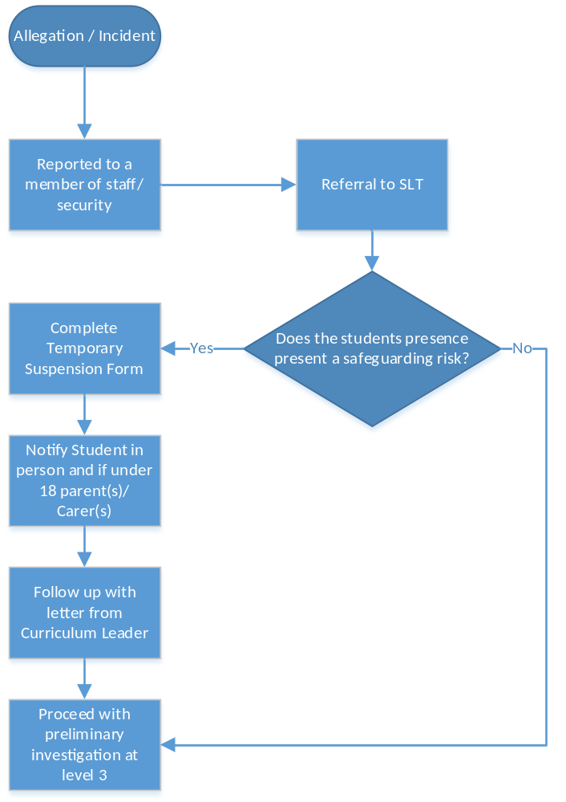
Dealing with Critical / Serious Incidents
Forms and letters available on BLinC and in T-Drive under Learner Journey Team and Disciplinary
- Cause for Concern Level 2 meeting notification
- Student Caution
- Student contract
- Temporary Suspension Form
- Witness statement template
- Suspected disciplinary matter meeting notification under local procedures
- Local procedures outcome – Proven
- Local Procedures outcome – exonerated
Policies and procedures to be read alongside this policy
- Fitness to participate in University life
- Post 16 Young People in Care and Care Leavers agreement
- Safeguarding Procedure for Buxton & Leek College
- Safeguarding Policy
- Absence and Attendance
- Social Media Policy

Appendix 1
Examples and classification of levels of misbehaviour
Advisory Notice
These examples are indicative only and are not exhaustive. Offences that can be dealt with under local procedures can include:

- Smoking in a non-smoking area
- Low disruptive behaviour
- Unexplained absences or lateness
- Talking in class when not appropriate
- Late submission of course work
- Not taking proper care of equipment or facilities
- Dropping litter, not disposing of litter appropriately
- Being inappropriately noisy or inconsiderate
- Contravening parking regulations
- Failure to observe instructions from staff in relation to safety or the use of facilities or resources
- Verbally abusive behaviour and/or inappropriate language
- Activities likely to disrupt teaching, learning for other students, study or research or any other activity of the University or obstructing any member of or visitor to the University in the performance of her/his duties

Cause for Concern Level 1
Continuation of offences in Advisory notes and or straight to level 1 if:

- Wilful disregard of Health and Safety Regulations including driving too fast on campus, tampering with fire extinguishers, fire alarms or electronic equipment, misuse of or altering electrical fittings or unauthorised use of electrical appliances

Cause for Concern Level 2
Continuation of offences in Cause for Concern Level 1 and or straight to level 2 if:

- Refusing to give name, address or course, or giving false information, to a member of the University staff
- Damage or defacement of equipment, facility or property belonging to an individual or the University
- Possession of illegal substances - this includes alcohol for under-18s
- Contravention of the University's Equal Opportunities Policies, including behaviour which is perceived as intimidating or harassing or which interferes with the personal and academic wellbeing of others
- Wilful removal of any equipment or property belonging to an individual or the University

Disciplinary (Level 3 Code of Conduct) offences that might be considered under University procedures can include

- Wilful contravention of the University's Equal Opportunities Policies, Codes of Conduct or other Regulations
- Behaviour which has a direct and damaging effect on the health and safety of others
- Advice of a criminal offence post enrolment which requires consideration of the potential impact on the University community
- Use of illegal substances or providing them to others
- Possession of an offensive weapon
- Use or threatened use of an offensive weapon
- Theft from individuals or the University
- Threatening or actual violent behaviour
- Failure to disclose a criminal conviction obtained after registration with the University
- Referrals from University Academic Offence procedures and the DSRL disciplinary process
- Any further or repeat incident as exemplified in the previous section
Temporary suspension: Does the student’s presence on course/site present a safeguarding risk to the University community or to themselves? If yes, see Temporary suspension guidelines

